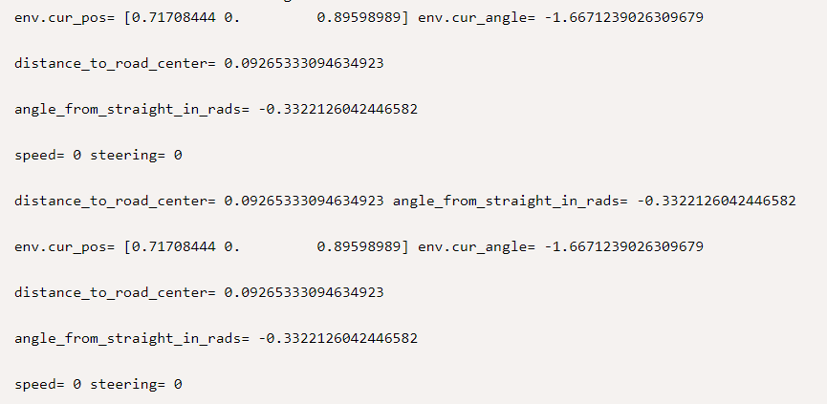

from gym_duckietown.tasks.task_solution import TaskSolution  
import numpy as np  
import cv2  
  
class LfChallengeNoCvTaskSolution(TaskSolution):  
 def __init__(self, generated_task):  
 super().__init__(generated_task)  
  
  
 def solve(self):  
 env = self.generated_task['env']  
 kv = 0.5  
 kw = 0.3  
 speed = 0  
 steering = 0  
 print('kv=', kv, 'kw=', kw)  
 print('speed=', speed, 'steering=', steering)  
  
 while True:  
 lane_pose = env.get_lane_pos2(env.cur_pos, env.cur_angle)  
 print('env.cur_pos=', env.cur_pos, 'env.cur_angle=', env.cur_angle)  
 distance_to_road_center = lane_pose.dist  
 print('distance_to_road_center=', distance_to_road_center)  
 angle_from_straight_in_rads = lane_pose.angle_rad  
 print('angle_from_straight_in_rads=', angle_from_straight_in_rads)  
 # Требуется по положению робота в полосе определить линейную и угловые скорости  
 # speed = 1 - kv * distance_to_road_center  
 # steering = 0 + kw * angle_from_straight_in_rads  
 print('speed=', speed, 'steering=', steering)  
 print('distance_to_road_center=', distance_to_road_center, 'angle_from_straight_in_rads=', angle_from_straight_in_rads)  
 env.step([speed, steering])  
 env.render()

